**Joint Bachelor/Master Thesis: Application of AI in Steel Surface Fault Detection**

Automated fault detection is an essential step of quality assurance [1]. The main role of fault detection for industrial processes is to make an effective indicator that can recognize faulty patterns. Thereafter, we can take proper action against future failure. To enhance the quality of the product, fault detection has attracted great attention from various industrial sectors such as the steel industry. After the steel has been produced, there may be defects on the surface and this will affect the quality of the product and its durability. Many traditional fault diagnosis techniques have been developed for checking the existence of a pattern in the defected product. However, they might fail to find the hidden patterns of the defective product [2]. In this joint thesis within Vac Schmelze company, we aim to detect different types of faults in produced steel surfaces using Machine Learning methods.

The thesis is done in two steps:

1. Labeling the produced steel surfaces to get familiar with the defect types
2. Doing a Literature review and applying the proper ML methods to recognize faults

**Prerequisites:**

* Programming with Python
* Knowledge of Machine Learning methods

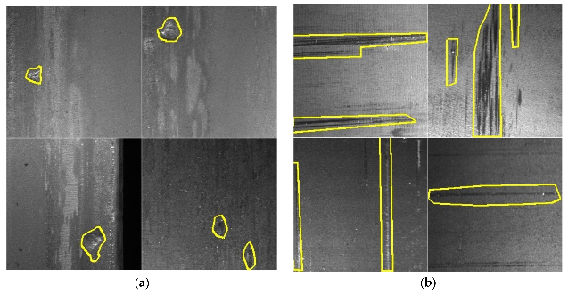

**Contacts:**

* Anahita Farhang, M.Sc

[anahita.farhang-ghahfarokhi@fb2.fra-uas.de](mailto:anahita.farhang-ghahfarokhi@fb2.fra-uas.de)

* Marius Lotz, M.Sc

[marius.lotz@fb2.fra-uas.de](mailto:marius.lotz@fb2.fra-uas.de)

* Jörg Schäfer, Prof. Dr

Gebäude 1, Raum 217

[jschaefer@fb2.fra-uas.de](mailto:jschaefer@fb2.fra-uas.de)

[1] Rahat Iqbal, Tomasz Maniak, Faiyaz Doctor, and Charalampos Karyotis. Fault detection and isolation in industrial processes using deep learning approaches. IEEE Transactions on Industrial Informatics, 15(5):3077–3084, 2019.

[2] You-Jin Park, Shu-Kai S Fan, and Chia-Yu Hsu. A review on fault detection and process diagnostics in industrial processes. Processes, 8(9):1123, 2020.