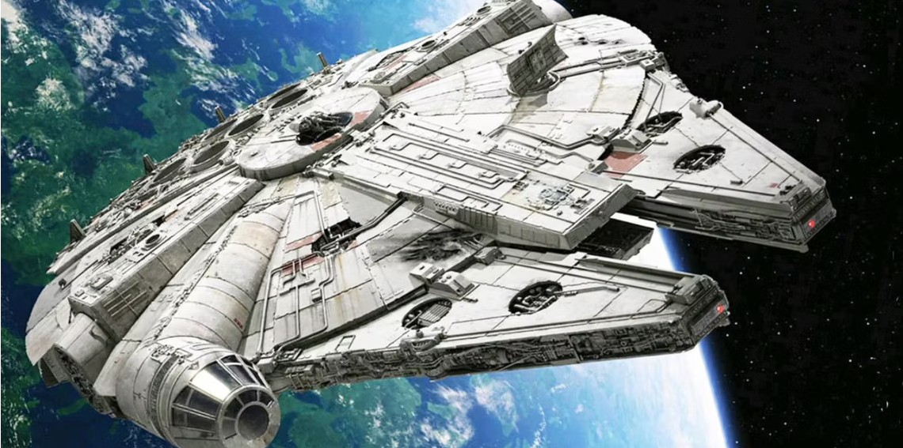

Label the image above with the following

- hyperdrive
- sublight engines
- main hold
- escape pods
- anti-gravity
- power core
- airlock
- weapons
- water recycling
- fuel
- hyperdrive vent
- cockpit

