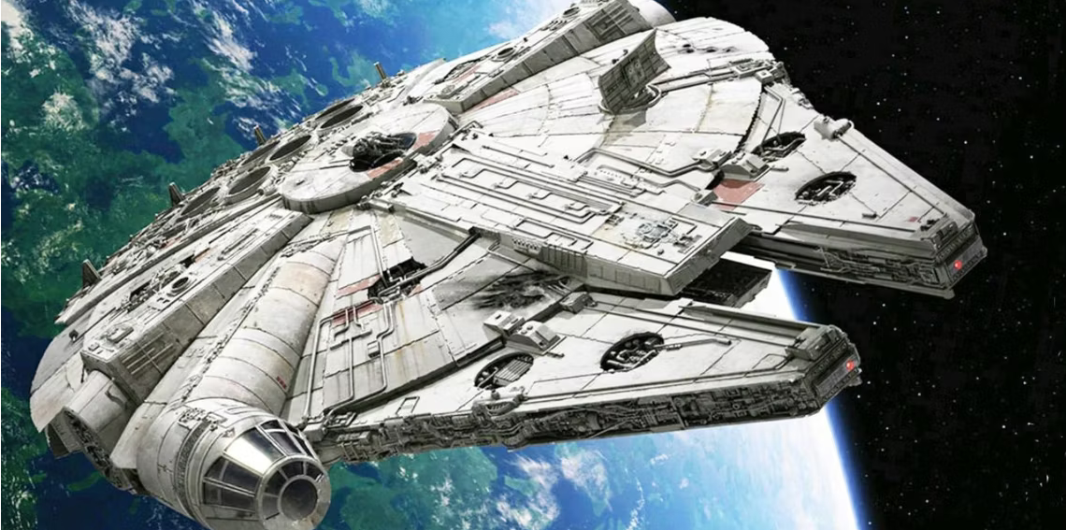

Label the image above with the following

1. hyperdrive
2. sublight engines
3. main hold
4. escape pods
5. anti-gravity
6. power core
7. airlock
8. weapons
9. water recycling
10. fuel
11. hyperdrive vent
12. cockpit