Progress test 2 (Units 4–6)
Listening
Track 3
Bill Wilson works for an advertising agency. He has asked his colleague, Alison Bates, for some advice. Bill is worried about the behaviour of their manager, Steve Parks. Listen to their conversation and decide whether these statements are true or false.
1 Bill is worried because he’s too busy.
2 Bill is making a formal complaint to Alison.
3 Bill is concerned that Steve has lied.
4 Steve and Bill often go on business trips together.
5 Steve and Bill visited a shopping mall together, on business.
6 Steve bought an expensive bag for a client.
7 Steve paid for a present for his wife with his company credit card.
8 Steve has a budget to buy meals and presents for clients.
9 Steve encouraged Bill to pay for personal items with his company credit card.
10 Bill is worried that Steve’s behaviour could hurt the company.
11 Bill wants Alison to talk to Steve about the problem.
12 As well as misusing his credit card, Steve is basically an incompetent manager in Bill’s view.
13 Alison thinks Bill should talk to Steve’s manager immediately.
14 Alison suggests that Bill speaks to Steve about his concerns.
15 Bill seems unlikely to take Alison’s advice.

Vocabulary
A Complete the articles with the words in the box.
bid commitments drop in individual influence juggle market
set up viral word of mouth

Web marketing in China
A recent ____________________¹⁶ study in China has found that ____________________¹⁷ marketing – for example video clips that circulate on social networking sites – is taking off more there than in Western markets. The ____________________¹⁸ of blogs and other user-generated consumer reporting is rapidly increasing and consumers trust ____________________¹⁹ views and opinions which speak to their ____________________²⁰ requirements more than advertising.
The home office
Knight Corporate Finance is a boutique business advisory firm that was ____________________²¹ by Paul Billingham and Adam Zoldan. However, the closest thing they have to an office where you could ____________________²² for a visit is Home House, a members' club in central London. And they only use it as a place to host meetings. Both men ____________________²³ a busy professional life and the demands of a young family. Working from home is a ____________________²⁴ – so far successful – to keep their ____________________²⁵ both at home and the office.

B Match the sentence beginnings (26–30) with the best endings (a–e).
26 The CEO was forced to resign after a) evidence of serious accounting irregularities
he became mired in and reported it to the authorities.
27 A junior researcher stumbled across b) the guts to report what she’d found.
28 At the trial, the CEO said that he c) the bad decisions he’d made and simply
wanted to come clean about clear the air.
29 The researcher said that it had taken d) the helm, the company was able to put
her several weeks to work up the past behind it and rebuild its image.
30 After a new CEO had taken e) allegations of serious accounting fraud.

Language
A Decide whether the underlined clauses are defining (D) or non-defining (N).
31 Bob Hatterson is someone who I can really trust to do a great job.
32 Peter James, a manager at Marks & Spencer, has some fresh ideas about marketing.
33 This distribution issue isn’t a problem we’re going to be able to solve easily.
34 Ikea, the giant of the flat-pack furniture industry, has been a global success for decades.
35 The website, launched only two months ago, has already generated hundreds of thousands of euros in profit for the company.
36 We want to avoid marketing products aimed only at teens.

B Choose the best words to complete the sentences.
37 By (working / to work) for a variety of employers, I’ve gained a lot of experience.
38 I’m not laid back enough (living / to live) as a freelancer. I’d always worry about the next job.
39 He’s a (hard-working / hard-work) manager so he gets a lot done.
40 It’s hard to keep up to speed but I enjoy (doing / to do) it.
41 People who employ you expect you (being / to be) on call all the time.
42 I tried to stop John making the payment but he (couldn’t / wouldn’t) listen to me.
43 Hiding the truth was a mistake. I (shouldn’t / wouldn’t) have done that but I did.
44 If I had been in your position, I (should / would) have asked for help.
45 Larry said he (couldn’t / shouldn’t) force Liam to stop taking big risks.

Reading
Read the article and choose the best answer – a, b or c – to the questions below.
46 What do companies not understand well, according to recent research?
a) What attracts workers to join a company
b) What makes workers want to stay in a job
c) What makes employees want to perform well in a job
47 Which of these things does the research show?
a) Workers and employees have different ideas about what encourages loyalty.
b) Employers aren’t interested in retaining talent.
c) Employees don’t consider it important to be motivated.
48 Which of these was among employees’ main motivations?
a) Recognition of individual achievement
b) The company’s ethics
c) The remuneration package
49 What do employees think of the way their abilities are applied to their work?
a) Companies don’t take full advantage of employees’ abilities.
b) Companies expect too much of employees.
c) Companies are basically good at making use of employees’ talents.
50 How have workers responded to the economic downturn?
a) A large percentage of people have accepted jobs way below their ability level.
b) Many have developed new expertise that they can apply to their work.
c) They have had to conceal lack of ability in order to compete in the job market.
51 What would cause 25 per cent of workers who aren’t actively looking for work to change jobs?
a) Disappointment with their current position
b) The opportunity to join a company with a strong brand
c) A job that offered more pay, a good career path or more flexible working conditions
52 Why does Brian Wilkinson say companies need to motivate workers to stay?
a) Because workers have skills that are valuable to the company
b) Because a well-motivated workforce is more productive
c) Because the danger of head-hunting by the competition is high
53 What does Brian Wilkinson recommend companies invest in?
a) Cost-cutting technology
b) Retaining key staff
c) Making employment more flexible
54 How does Brian Wilkinson recommend companies deal with the ageing population?
a) Attract young talent with extensive training packages
b) Freeze the retirement age
c) Plan to use short-term personnel solutions
55 What does the article say about employees working away from the office?
a) It’s increasingly popular with workers.
b) Many employers are already strongly encouraging it.
c) It isn’t likely to be a permanent solution for most companies.

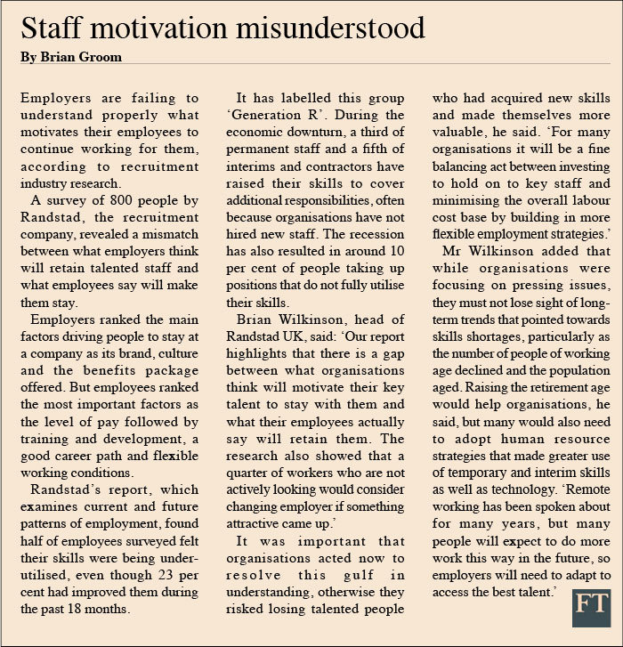

Skills
A Read the introduction to a presentation. Write the letter (a–h) of the correct technique next to the number (56–60) of the extract from the text. You will not need all the techniques.
Good morning. My boss is an optimist. He says ‘The glass is half full.’ His boss is a pessimist. She says ‘The glass is half empty.’ My name’s Becky Mendez. I’m a marketing consultant and I say ‘Your glass needs re-sizing.’⁵⁶
According to inventor Edwin Land, ‘Marketing is what you do when your product is no good.’⁵⁷ For all of us who work in marketing, that’s a pretty strong statement, isn’t it?⁵⁸ But is Land right? Are we working in marketing because our product is no good⁵⁹?
Now, you may or may not know that Land was the inventor of the hugely successful Polaroid camera. You probably didn’t know that in the mid 1990s, the company had an annual revenue of $2.31 billion⁶⁰? Obviously Polaroid was doing something right …
a) Involving the audience
b) Referring to surprising facts or figures
c) Emphasising key words
d) Using humour
e) Calling for action
f) Quoting someone
g) Inviting agreement
h) Telling an anecdote

56 _____
57 _____
58 _____
59 _____
60 _____

B Complete the sentences with the words in the box.
go ’m listening sense sound understand
Greg Shelly, hi. Good to see you.
Shelly We need to talk about this afternoon’s presentation, Greg.
Greg I __________⁶¹ you’re feeling a bit anxious about it.
Shelly Yes, more than a bit anxious. I don’t think we’re ready for it!
Greg I __________⁶². Please __________⁶³ on.
Shelly We’re presenting together but we haven’t practised!
Greg I’m not sure I __________⁶⁴. We’ve given this sort of presentation quite a few times before.
Shelly Yes, but not in front of 300 people. I’m not sure I want to go through with it.
Greg You __________⁶⁵ as if you’re really worried about it.
Shelly I am!

Writing
You are planning a monthly update meeting later in the week with three people you manage: Uma, Phoebe and Neil. The day and time have already been agreed. Write a polite, neutral e-mail (150–200 words) to them. Include the following information.
• Time: 10:00–12:00. Place: Room 247. Need to start and finish on time. (People have been late in the past and have wasted time during the meeting.)
• Team should update you on all of their projects.
• Everyone should bring their latest sales figures for presentation.
• Larry Collins, your regional manager in Manchester, has resigned at short notice; need to discuss interim duties to take up the slack; come prepared to make suggestions regarding any affected work.
• Need to discuss (not for the first time) the continuing problem of the kitchen area (not everyone is cleaning up after themselves; someone is leaving dirty dishes in the sink daily).
• Offer the opportunity to ask questions and share comments and say you’re looking forward to the meeting.

